***ASSIGNMENT 3:***

***TURTLE GAMES PROJECT***

***SEPTEMBER 2022***



**Javier Conde Pascual**

**LSE Data Analytics Career Accelerator**

**London School of Economics and Political Science**

*I, Javier Conde Pascual, certify that this is an original piece of work. I have acknowledged all sources and citations. No section of this assignment has been plagiarized.*



**TABLE OF CONTENTS**

Chapter 1. Scenario and system set up 1

Chapter 2. Analysis approach3

* 1. **Customer data analysis**
     1. First approach and insights to provided data4
     2. Customer Clustering5
     3. NLP using Python on customer reviews10
  2. **Sales data analysis**
     1. Exploratory Data Analysis (EDA) on sales with R14
     2. Data set normality and advance plotting14
     3. MLR model and value prediction14

Chapter 3. Insights and recommendations17

List of figures20

Word count:

Own words:

Chapter 1

**Scenario and system set up**

Background, scenario, and context provided beforehand for this report are available [here](https://fourthrev.instructure.com/courses/438/assignments/1711). The business problem and key questions for the analyst team and the data are also provided, Figure 1.1. below.

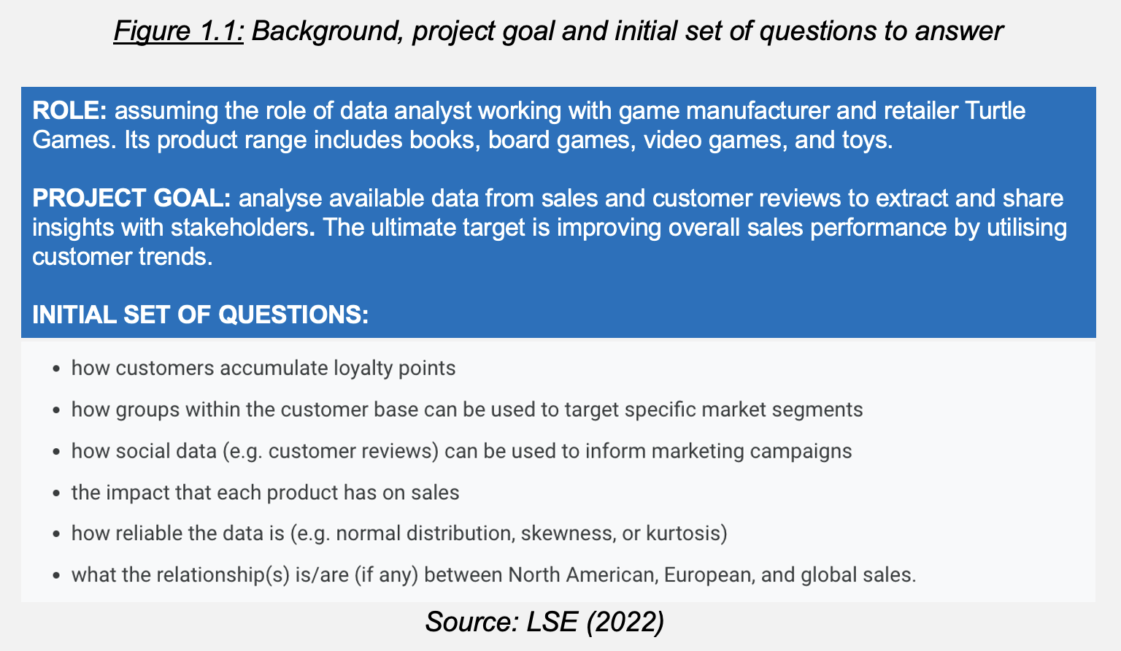

All project files are stored in [GitHub](https://github.com/JavierConde1976/LSE_DA301_assignment_EDA_Javier_Conde)to control overall project progression, different steps we are completing along the way and any changes we make to the Python and R (using Jupyter/RStudio) code blocks.

Now once we have prepared the central Python/R repository in Github where the project will be coded, let’s study the analytical approach used.

Chapter 2

**Analytical approach**

As in previous projects, this approach has four key points:

1. Bringing stakeholders (marketing and sales team) and data analysis team together through understanding the importance and risk-reducing advantages of methodical and thorough data analysis and data quality processes
2. Provide stakeholders with rigorous, accurate and realistic analysis on the data files provided through Python and R:
   * turtle_sales.csv (details of video games sold globally)
   * turtle_reviews.csv (details on customer reviews across products)

Aim is providing actionable insights and recommendations from them to bring measurable value to the business to reach the project goal.

1. Assessing the quality of the data and results obtained. To achieve best results this project will be divided in two parts: customer data analysis and financial analysis on company sales.
2. Reports/presentations material to be created as accessible as possible through very legible fonts (Arial), big font sizes (10-12 onwards when possible), clear head titles and colors that are color-blind and color-contrast friendly among other features.

With file preparation for Github, Phyton (Anaconda/Jupyter) and R (RStudio) completed (Figures 1.2 and 1.3 below), let’s now analyze and visualize the data provided.

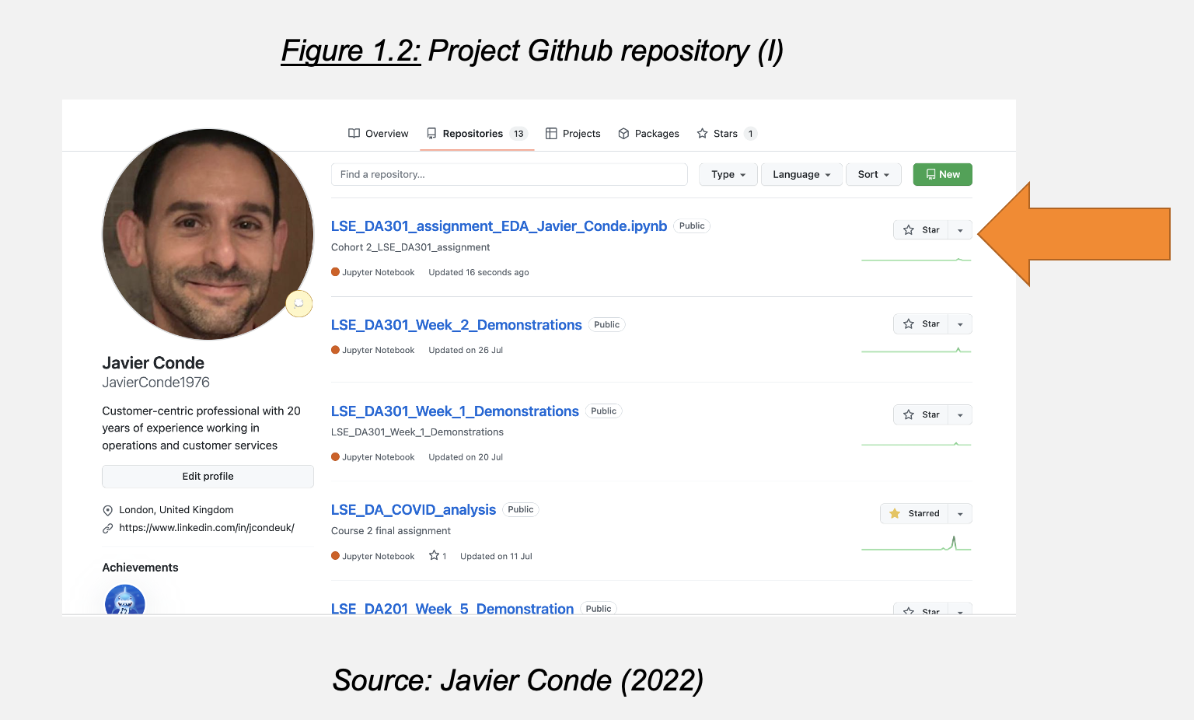

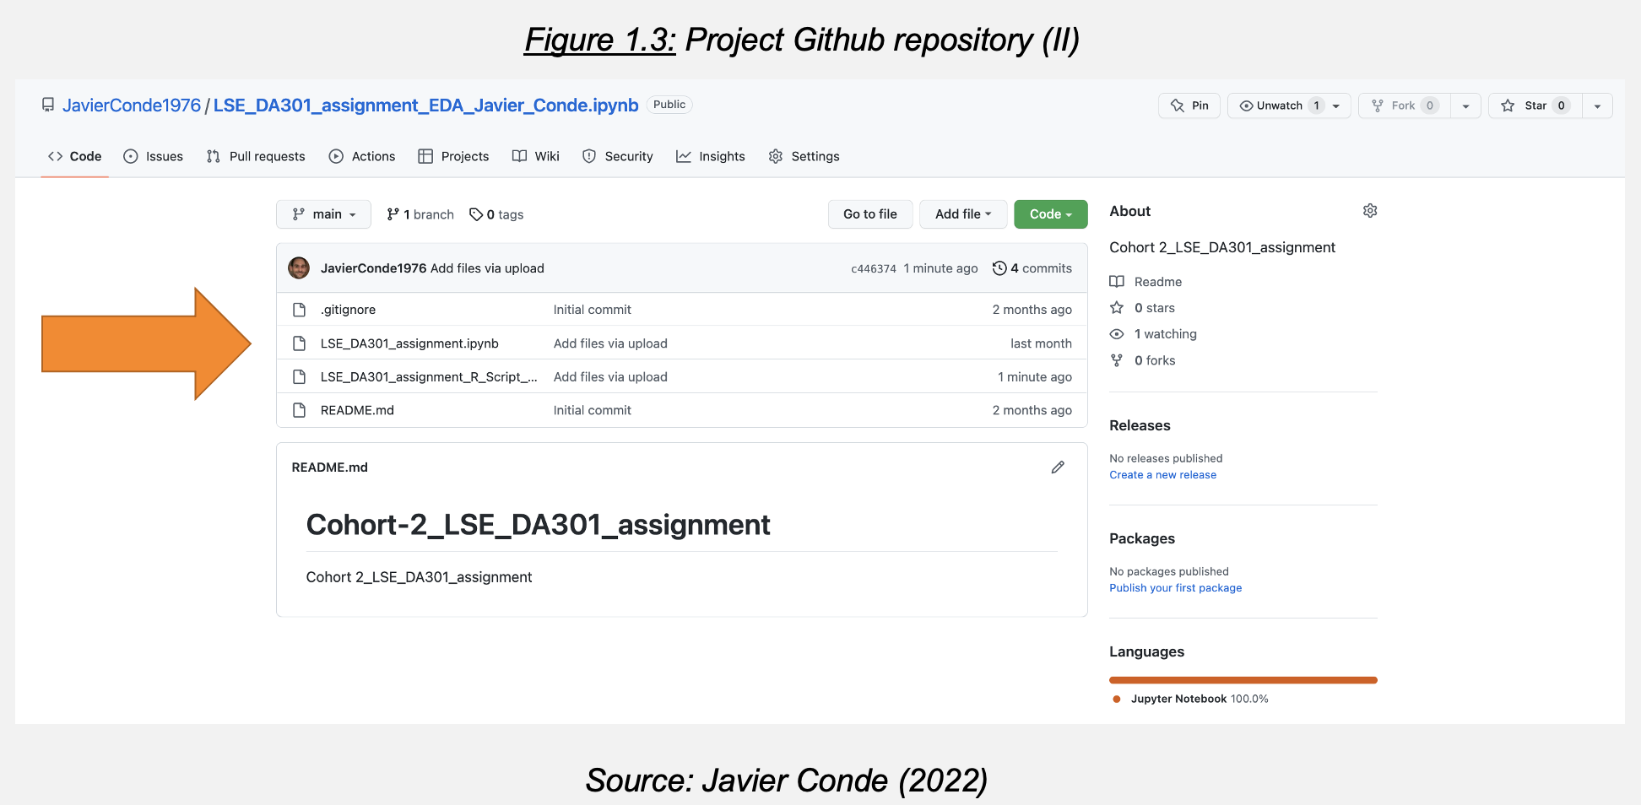

**2.1 Customer data analysis**

**2.1.1. First approach and insights to provided data**

The file turtle_reviews is cleaned and re-imported before starting analysis (Figures 2.1 and 2.2).

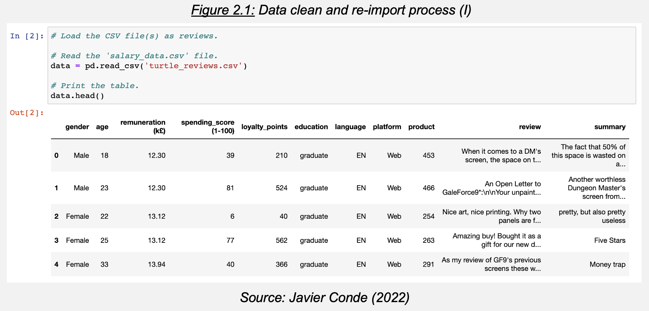

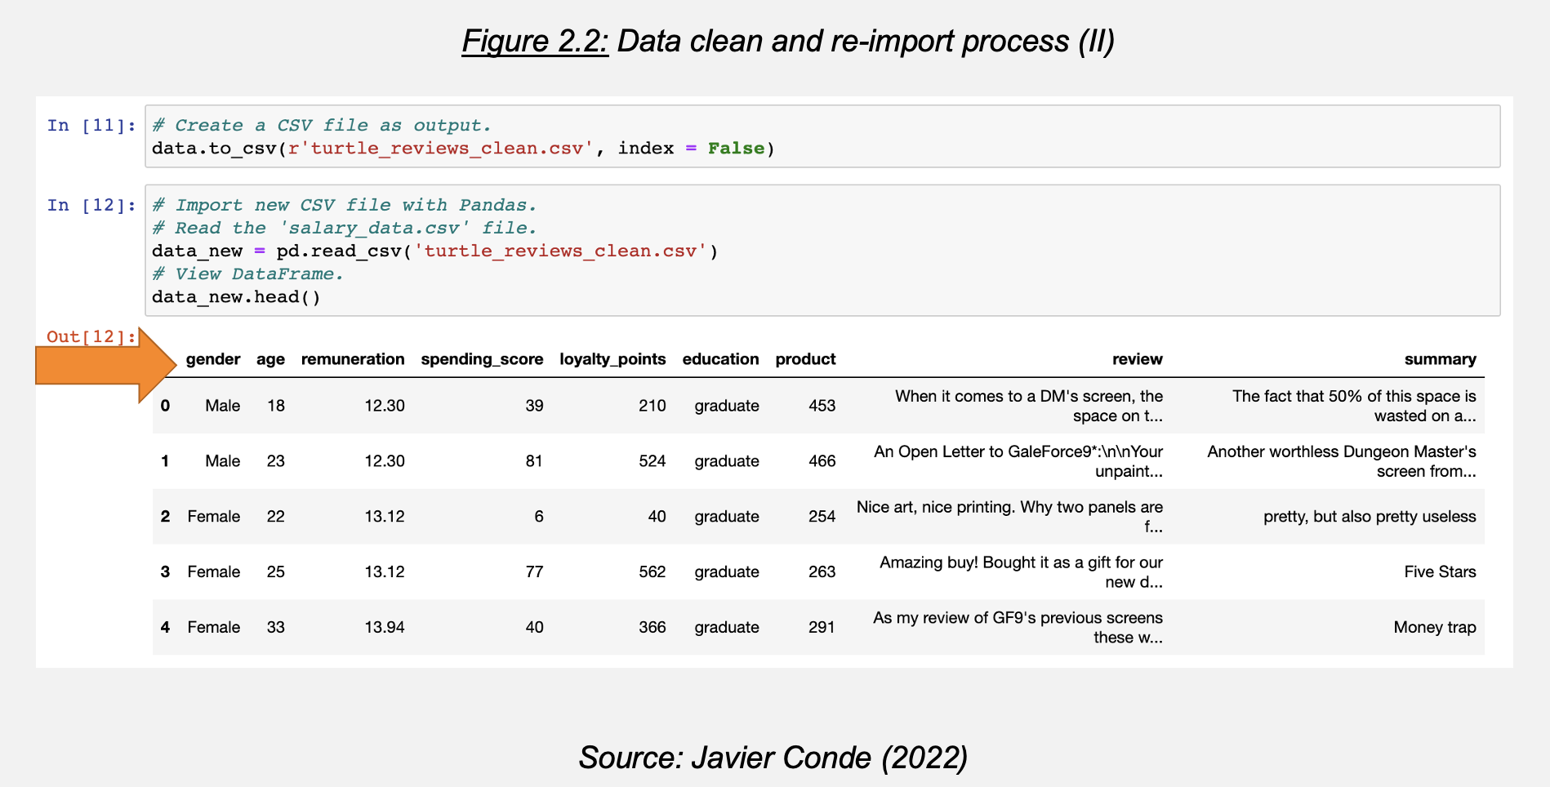

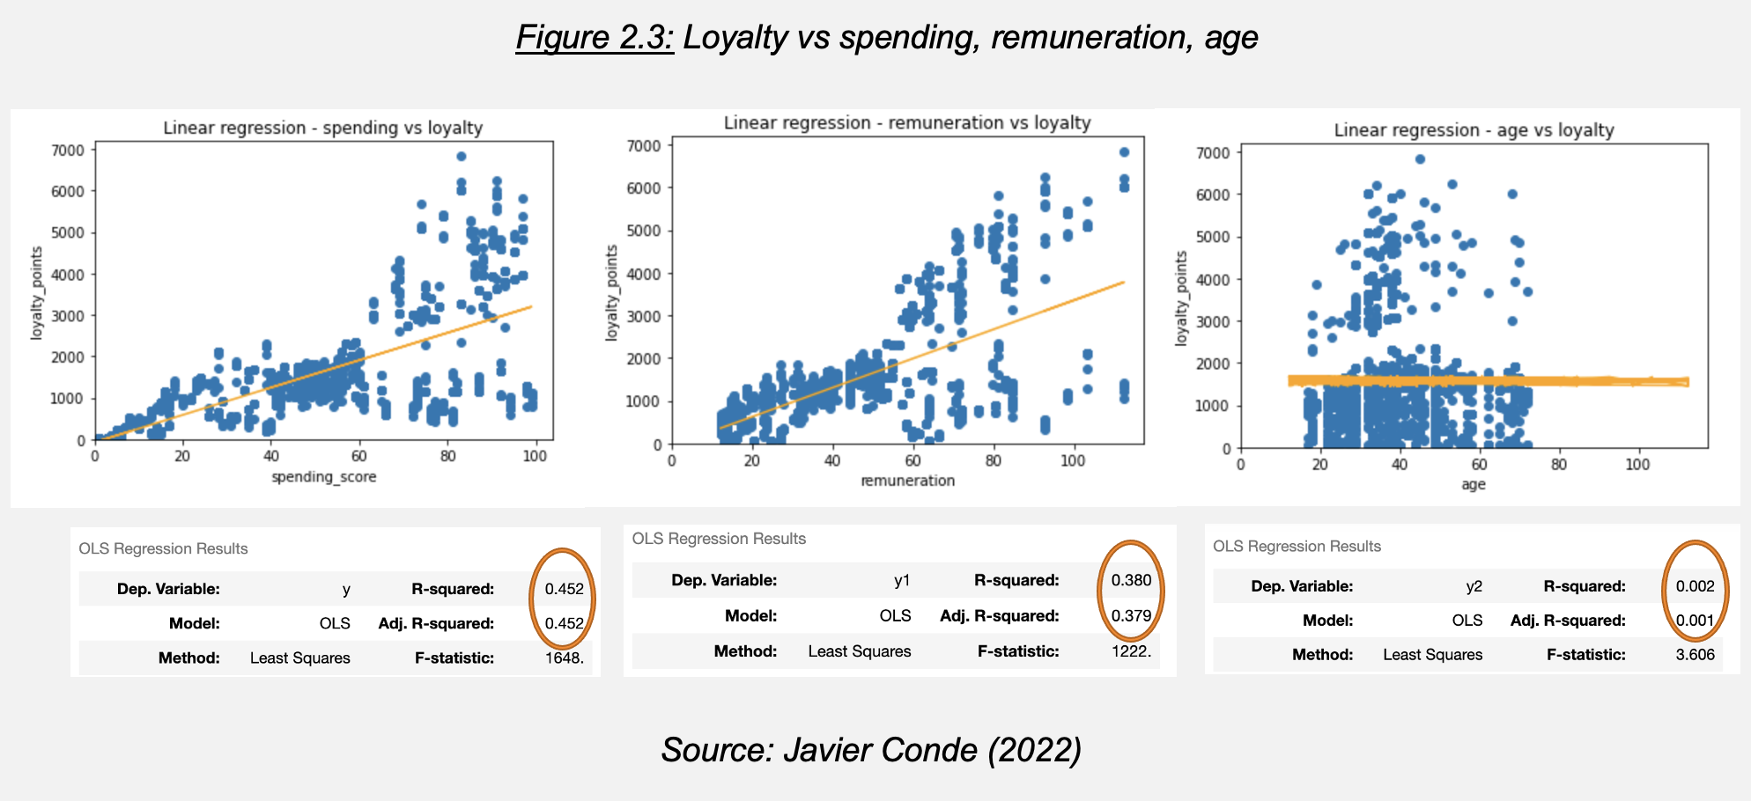

There is a slight correlation between spending and remuneration with loyalty (Adjusted R Squared measure 0.45 (spending) and 0.37 (remuneration)) but almost no correlation with age (R2 0.001) (Figure 2.3 above). As marketing department requests to study spending/remuneration further, let’s now identify groups within the customer base that can be used to target specific market segments regarding both variables through k-means clustering.

**2.1.2. Customer Clustering**

Let’s study further the relationship between these two variables with Seaborn through a regression scatterplot and a pairplot (Figures 2.4 and 2.5).

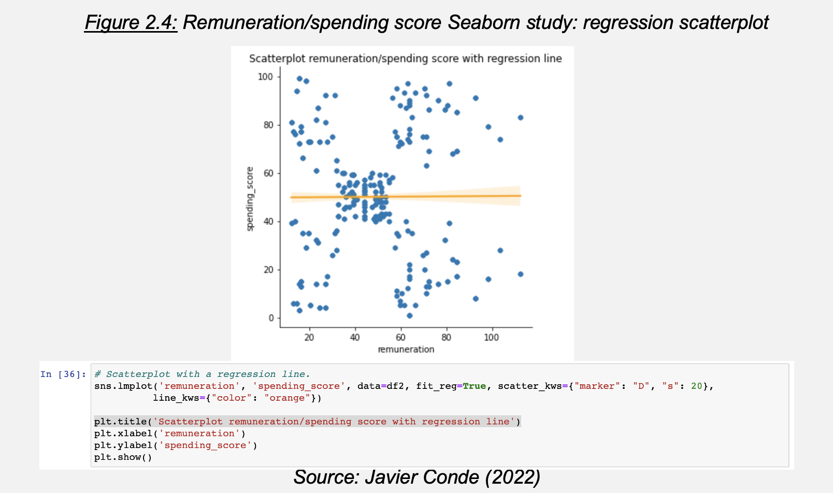

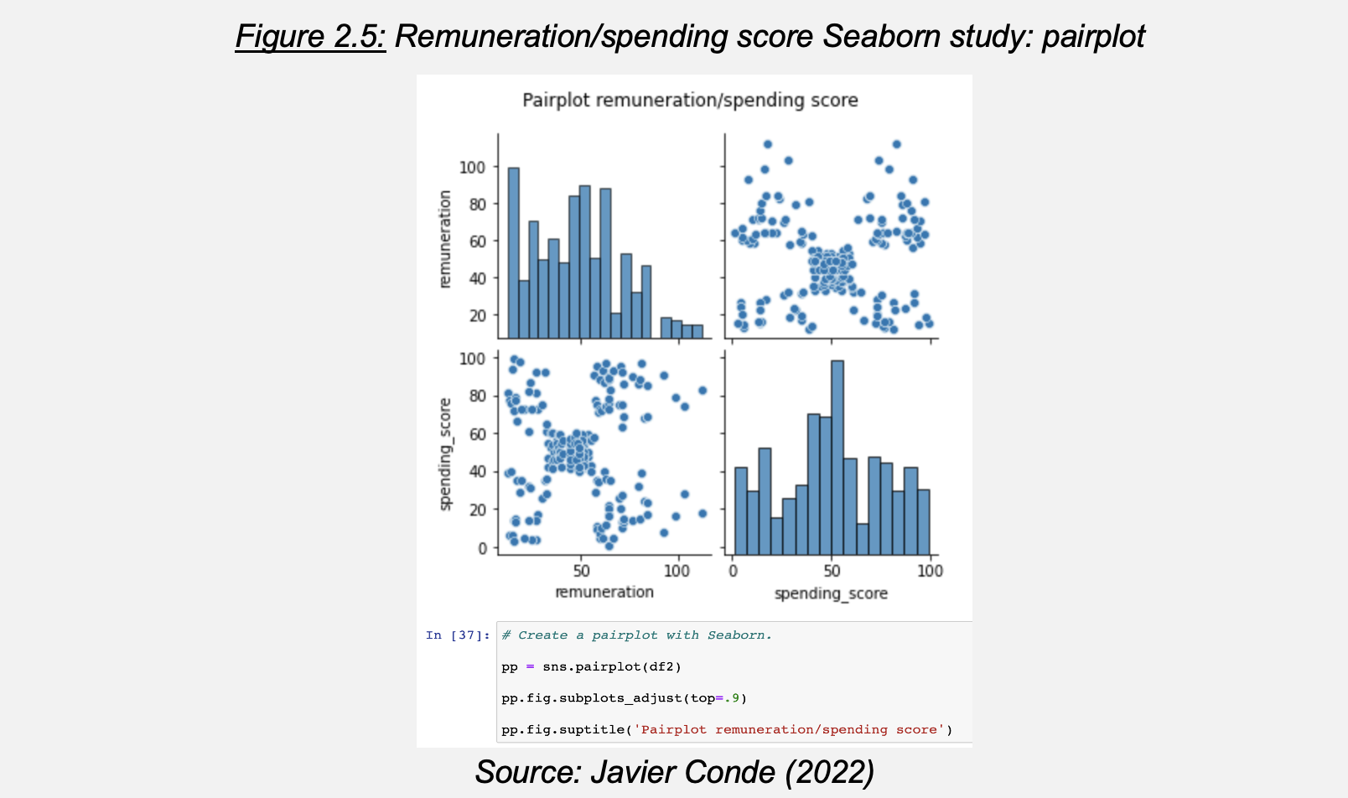

The pairplot uncovers four/five possible customer clusters. Through the Elbow and Silhouette methods it is determined that optimal cluster number (‘k’) is 5 (Figure 2.6). Now let’s evaluate this value and other alternatives (i.e., 6/7) through a k-means model.

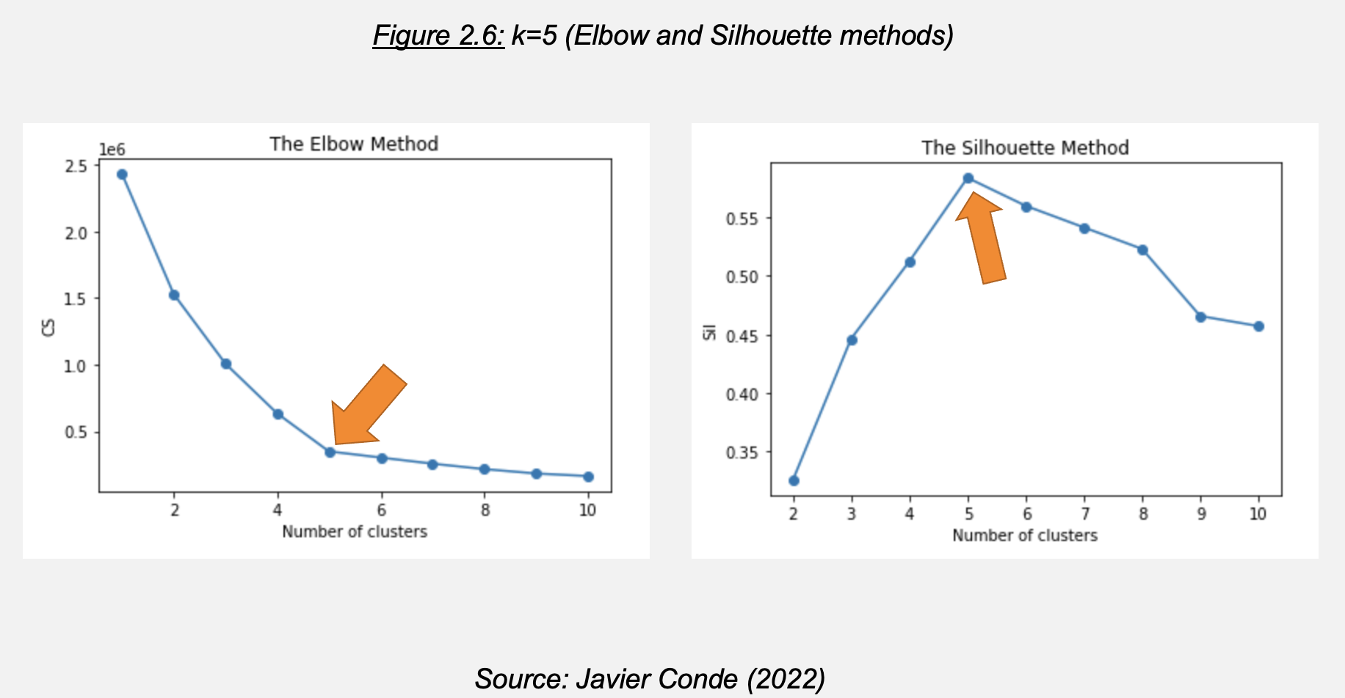

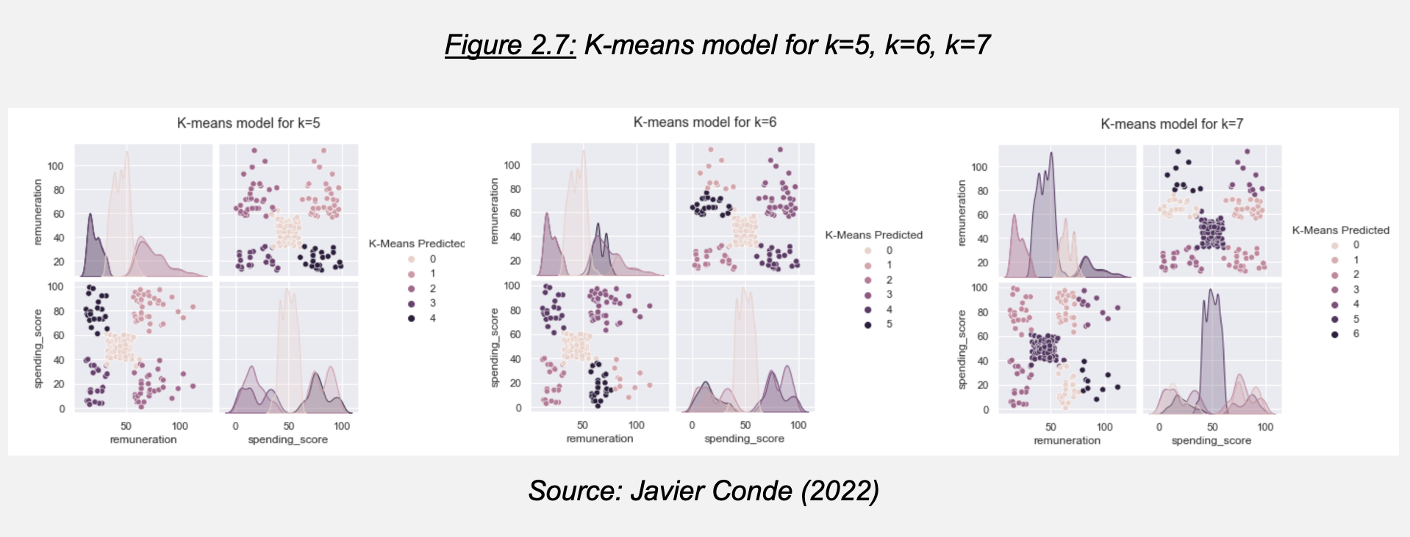

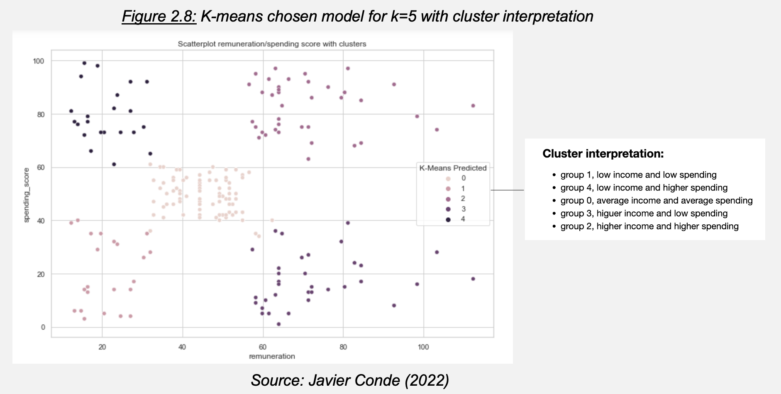

Figure 2.7 and Figure 2.8 show that k=5 returns the best customer grouping as it provides a good separation between groups. Therefore, it would be recommended to Turtle Games investigating 5 possible customer clusters in relation to their remuneration and spending score (as also evidenced by the result of the Elbow and Silhouette methods).

Now as the marketing department has requested more information to approach future campaigns, let’s study the customer reviews provided to analyze sentiment behind them through Natural Language Processing (NPL).

**2.1.3. CNPL using Python on customer reviews**

Focus of the analysis will be ‘review’ and ‘summary’ columns from the ‘turtle_reviews file’. A new data frame is created only with them, removing lower cases, punctuation, and cleaning duplicates prior to tokenization (Figure 2.9). Then a word cloud with stop words removed is created for visibility (Figure 2.10). Analysis on count of 15 most frequent words and polarity/sentiment in both columns follows (Figure 2.11).

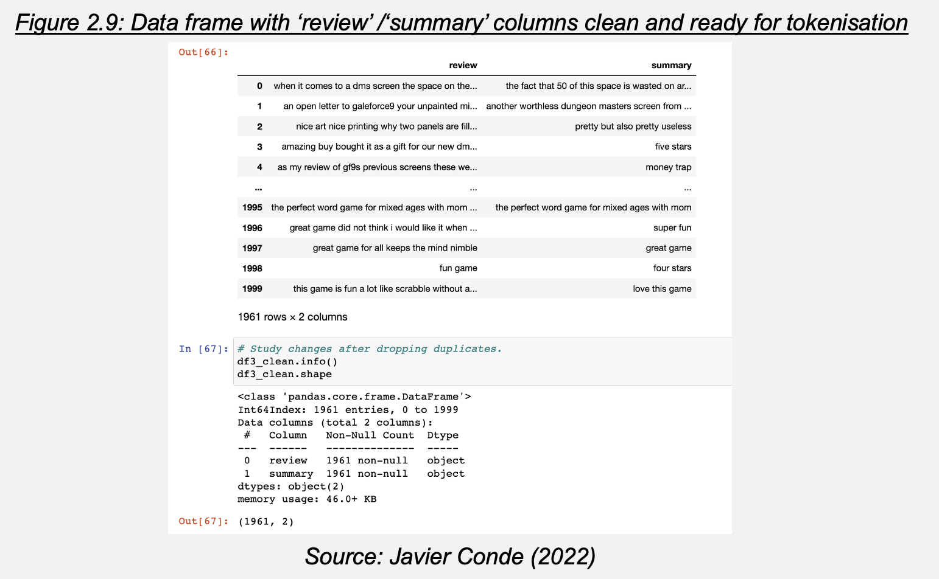

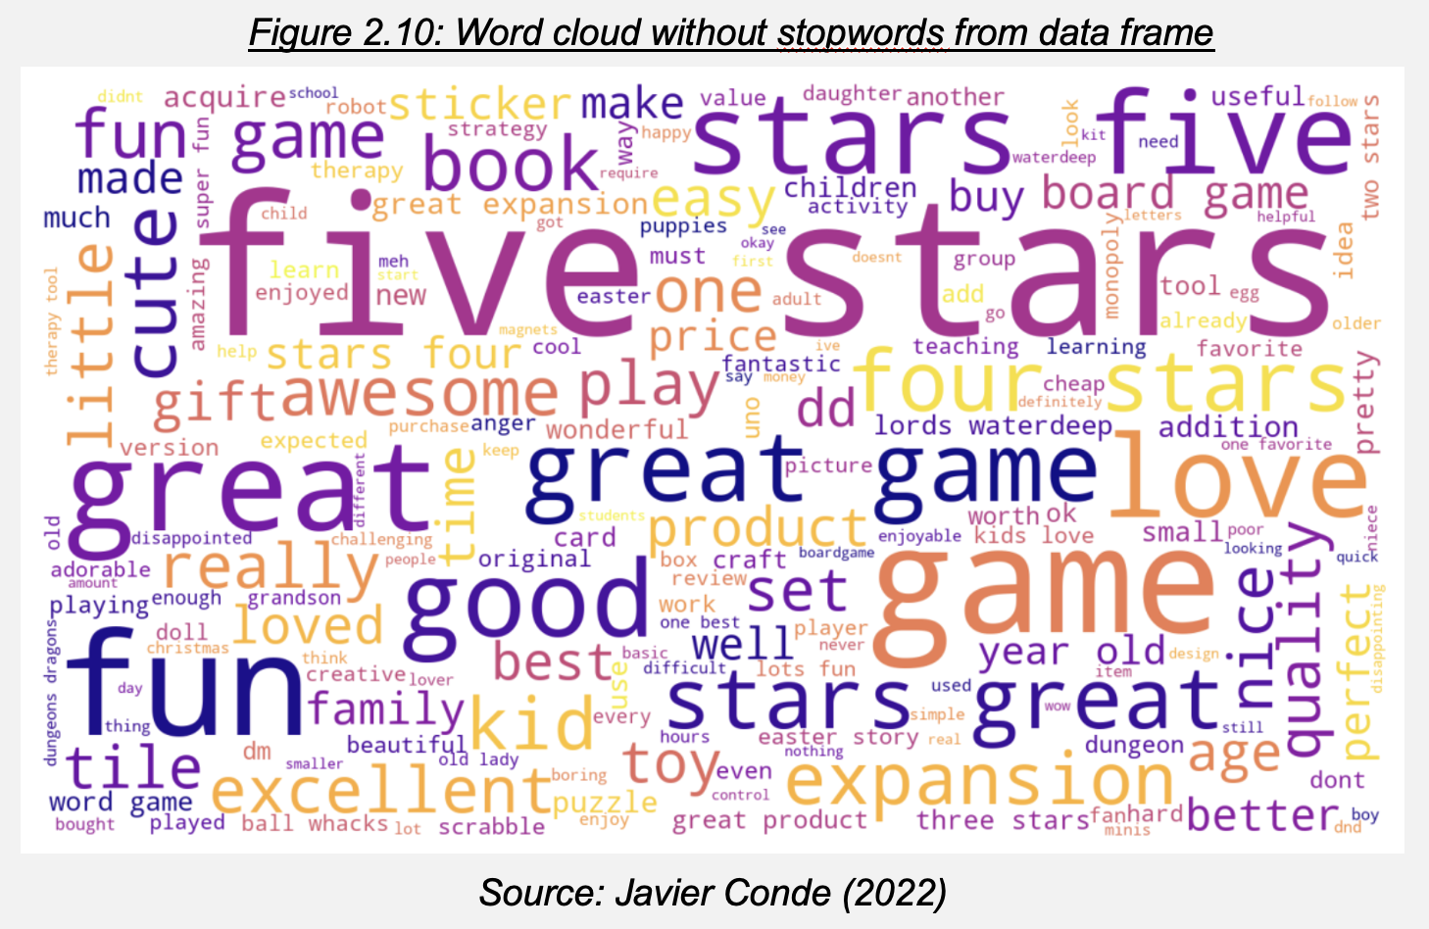

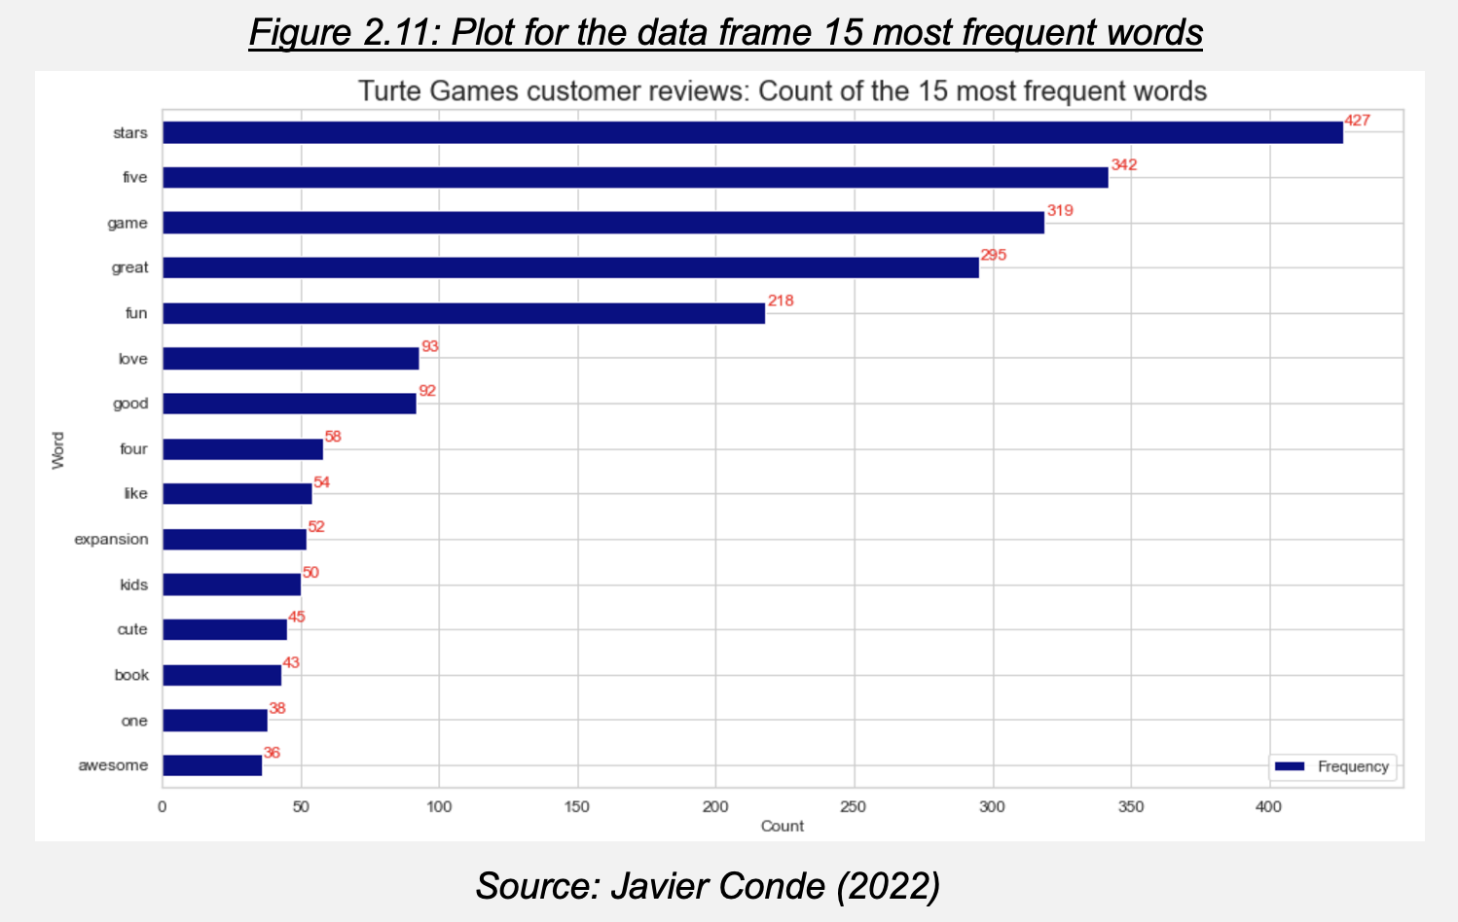

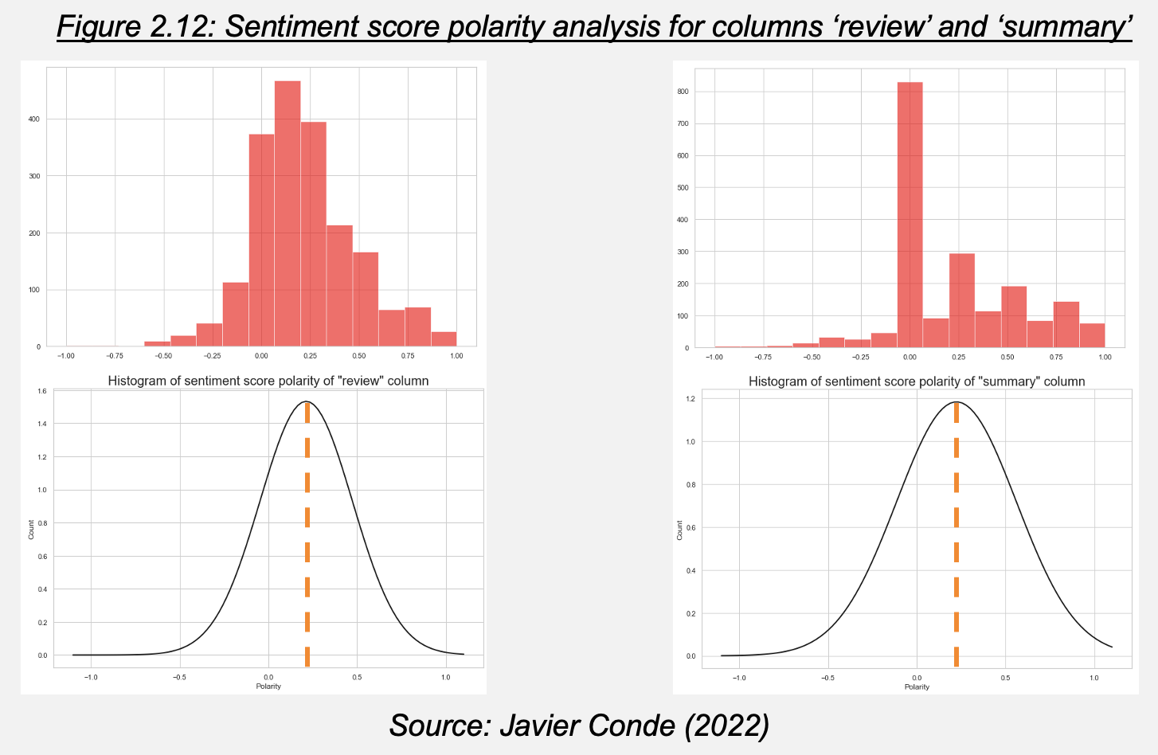

The first most frequent words being “stars” and “five” and sentiment/polarity score Mean in both columns between +0.2 to +0.25 signal to a slightly positive sentiment towards Turtle Games products. As this data would be useful for the marketing department, further analysis on customer reviews to better understand points of improvement and ‘best of’ comments is recommended.

Let’s now analyze sales performance from the company products, this time using R as it is the preferred tool for the sales department.

**2.2 Sales data analysis**

**2.2.1. Exploratory Data Analysis (EDA) on sales with R**

After importing the relevant packages and exploring structure and summary of the provided data (Figure 2.13), we create a subset containing products ID, creation platforms, and sales figures (European Union (EU), North America (NA) and Global) (Figure 2.14).

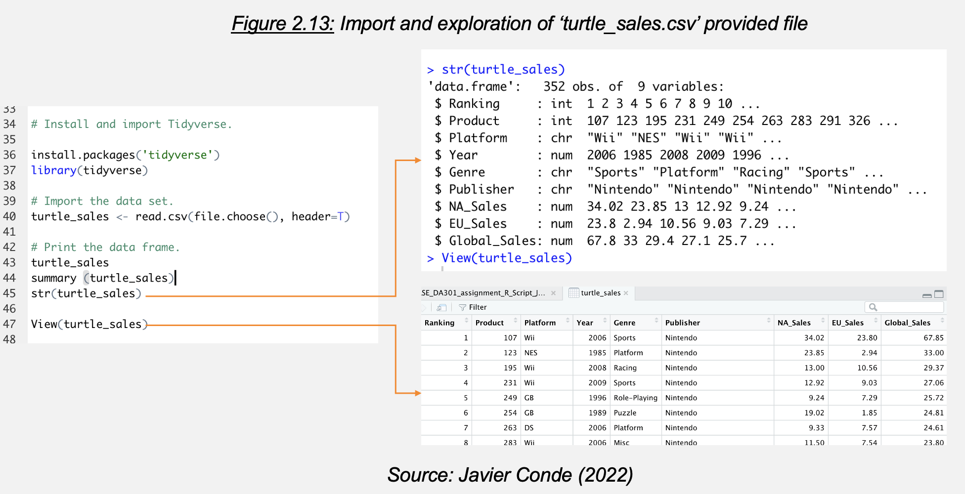

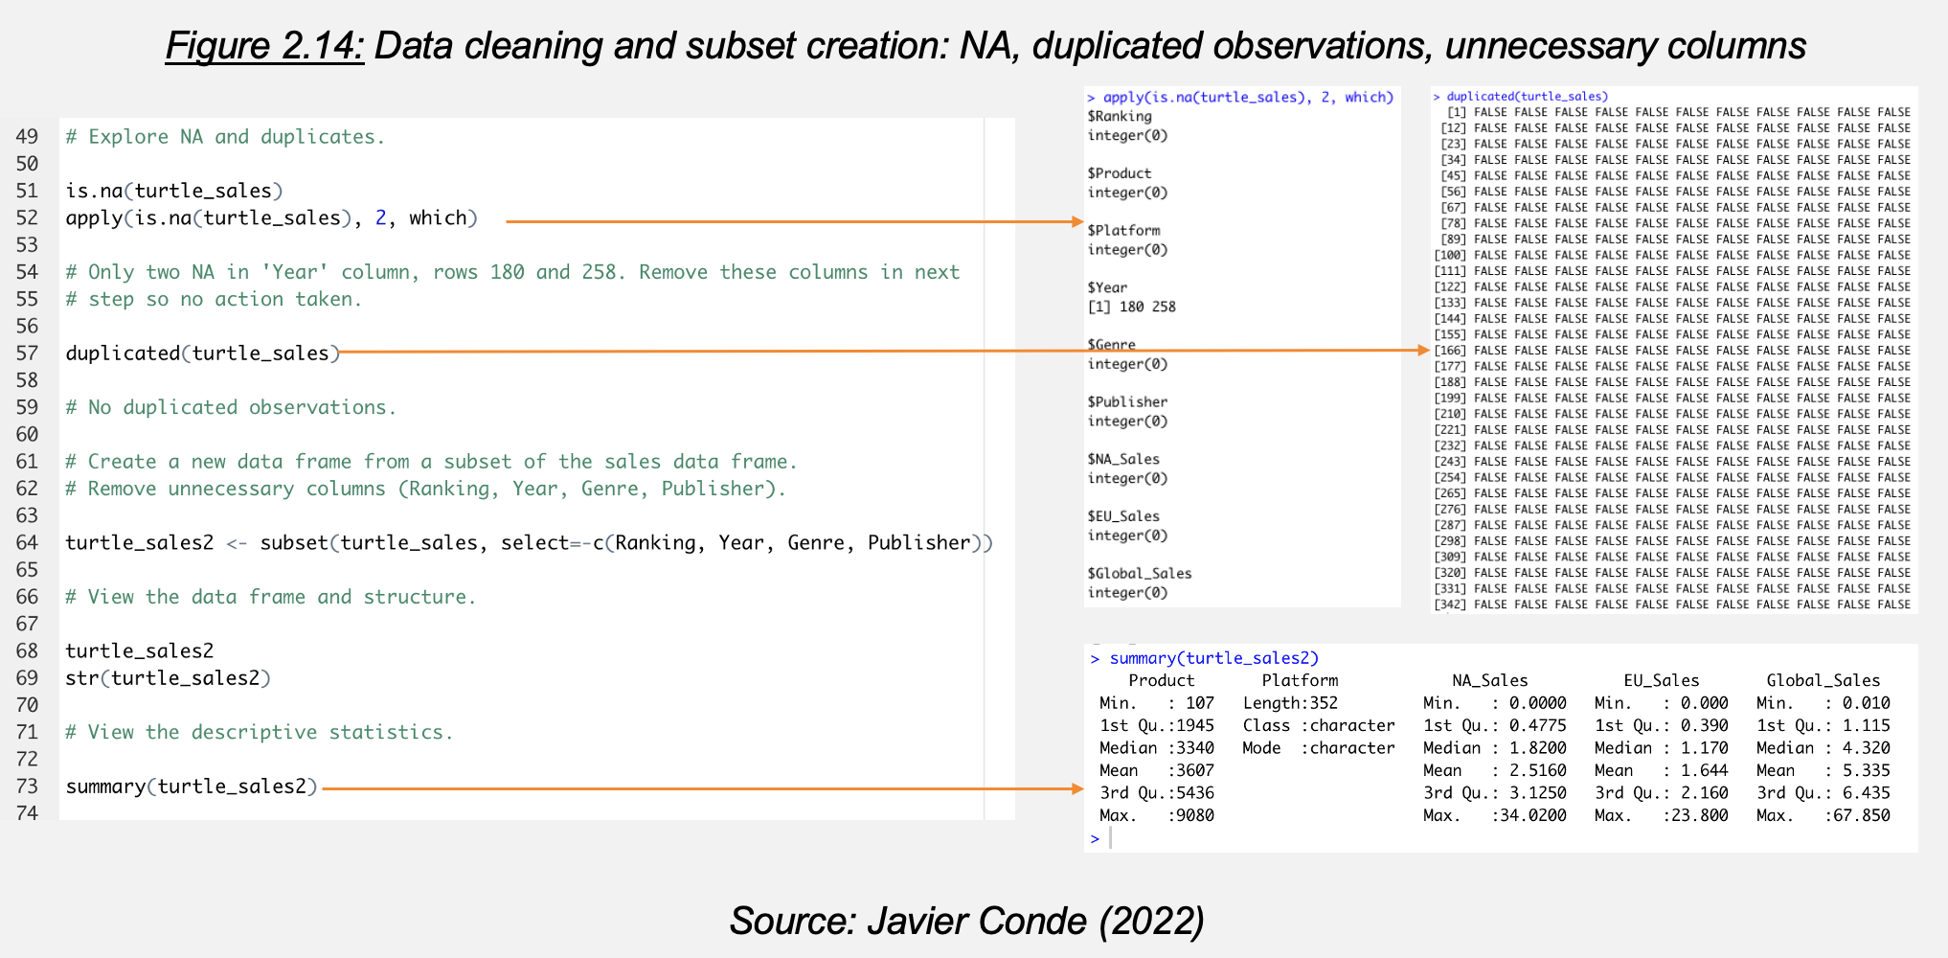

This clean data set is studied through exploratory scatterplots (Figure 2.15), histograms (Figure 2.16) and boxplots (Figure 2.17).

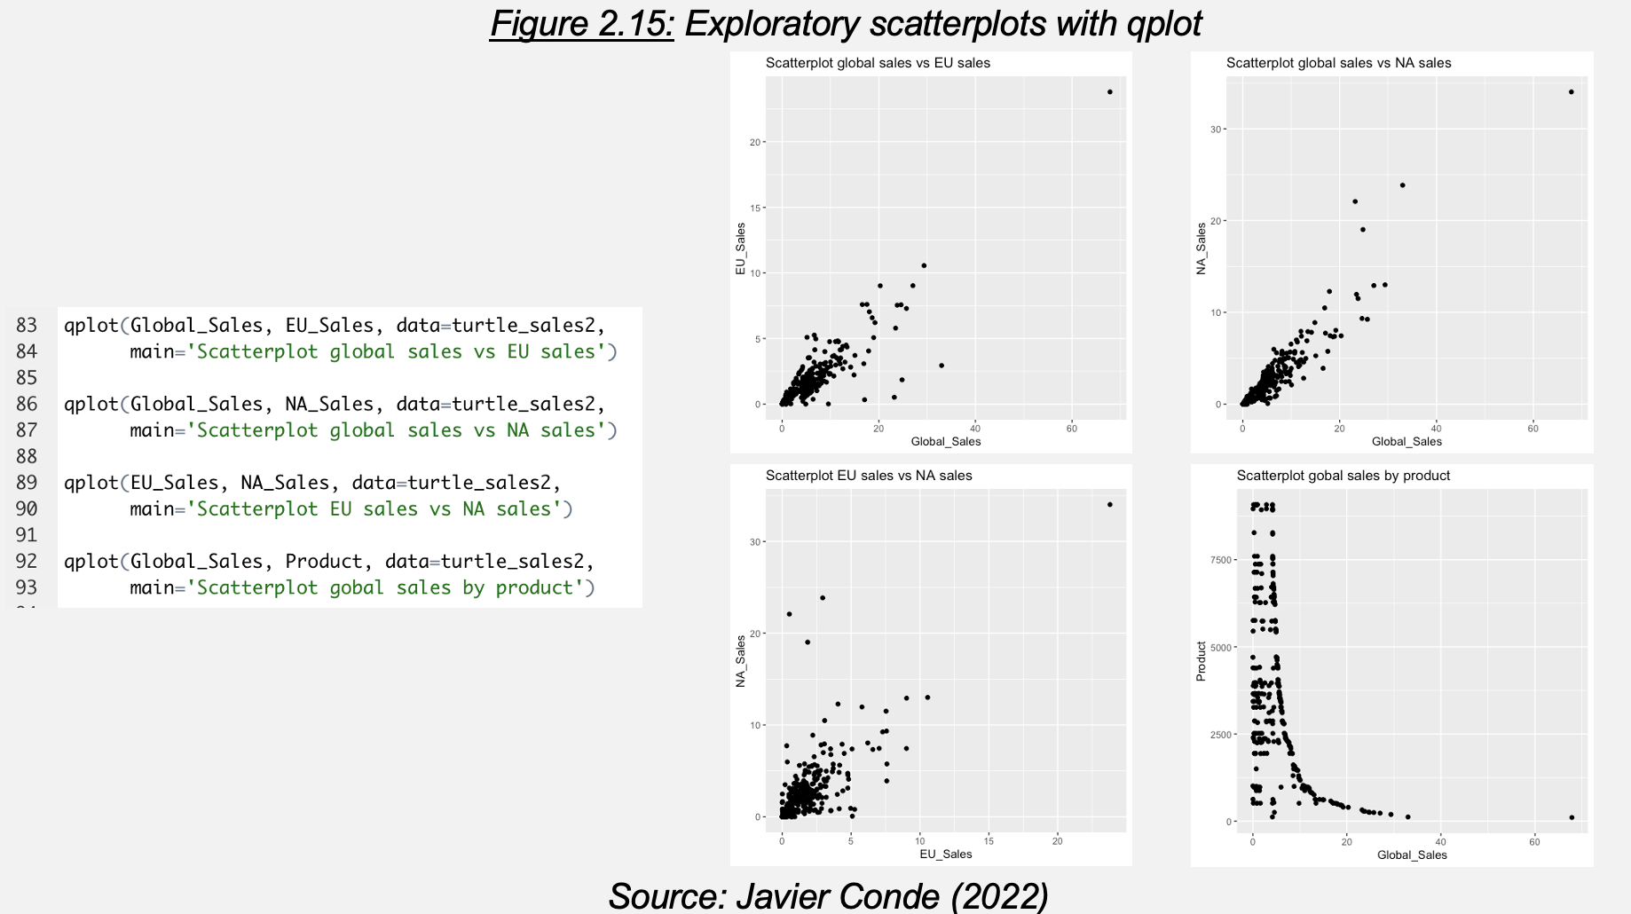

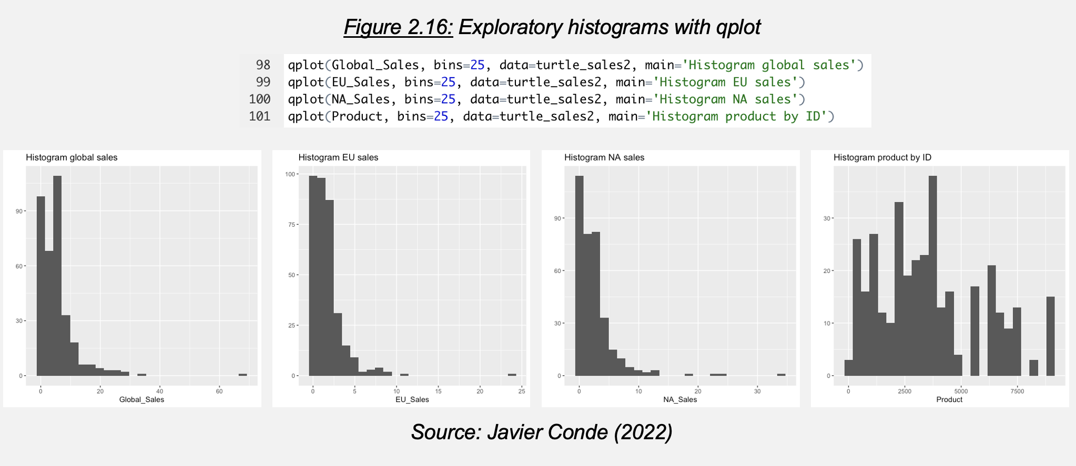

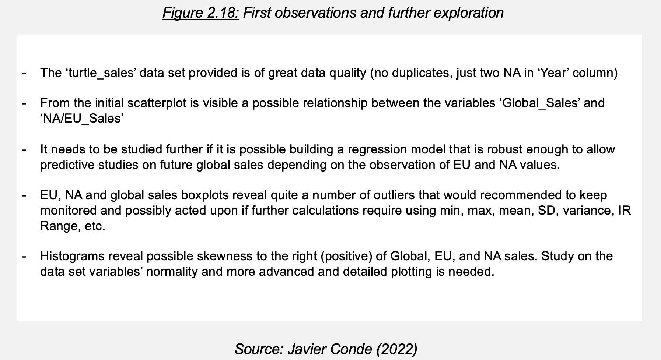

This first approach reveals more study needed on normality with a more detailed plotting package (Figure 2.18). Let’s explore these topics.

**2.2.2. Data set normality and advance plotting**

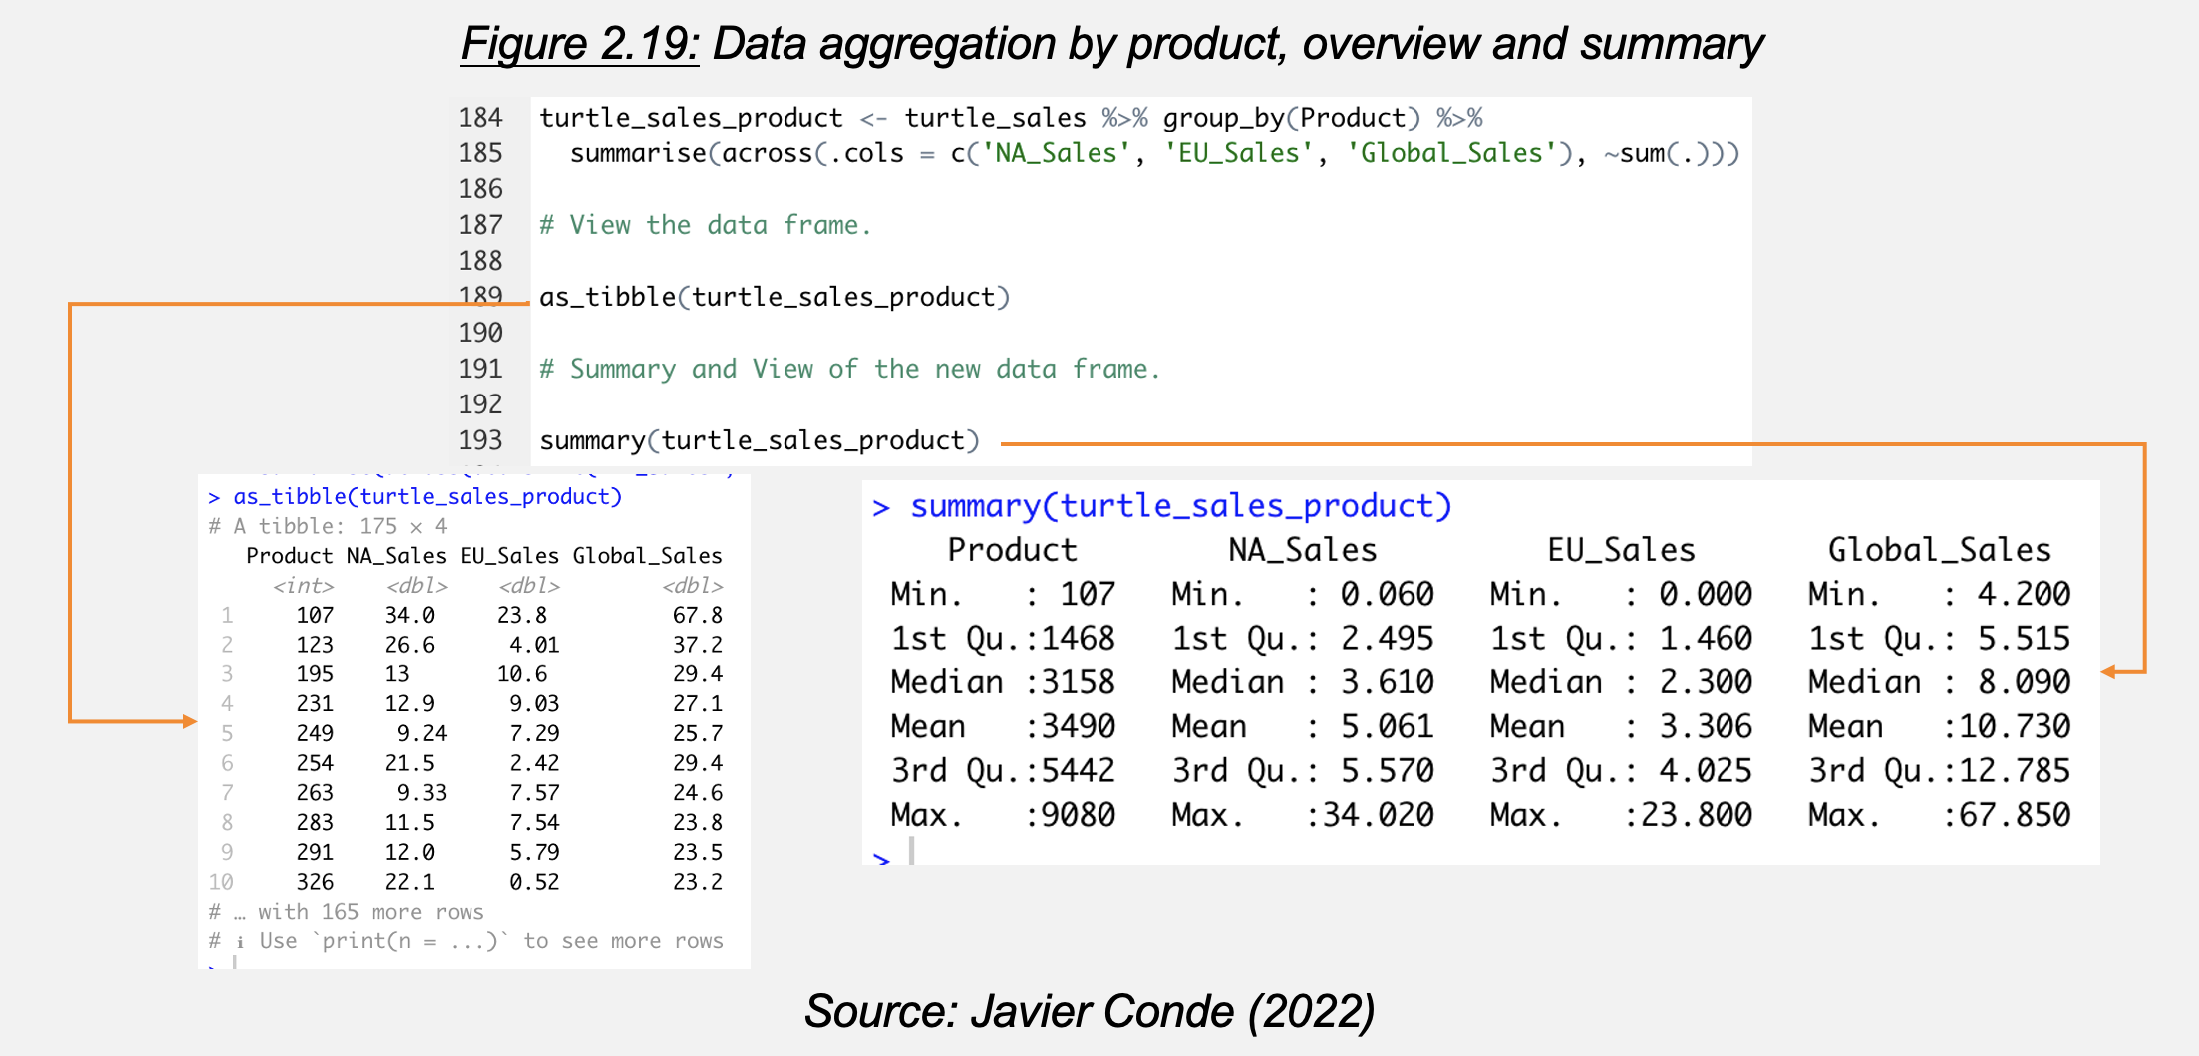

To facilitate the analysis let’s aggregate the sales data based on product and check results with as_tibble() function. Aggregated data frame ‘turtle_sales_product’ (Figure 2.19) is used for analysis on QQ plotting, Shappiro-Wilk testing, skewness and kurtosis, variables correlation, and advanced plotting (Figures 2.20 to 2.25).

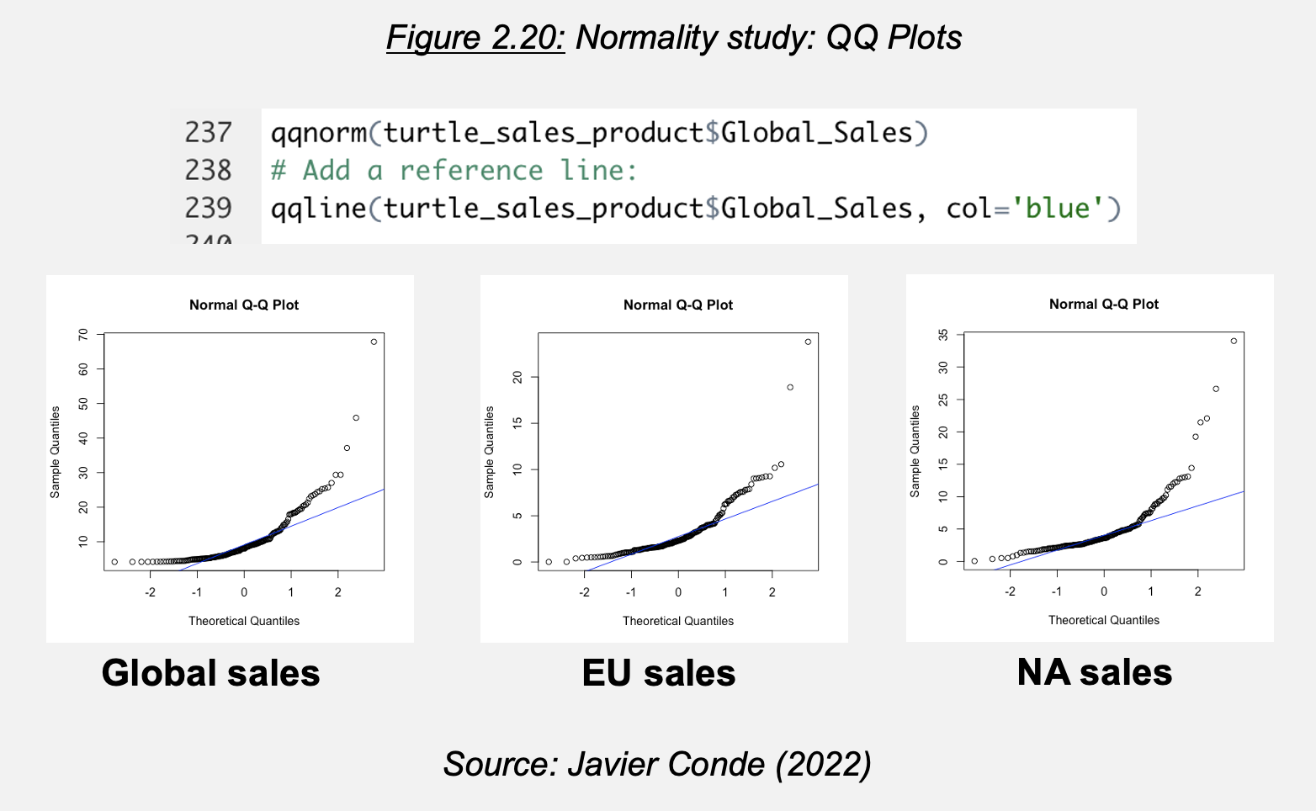

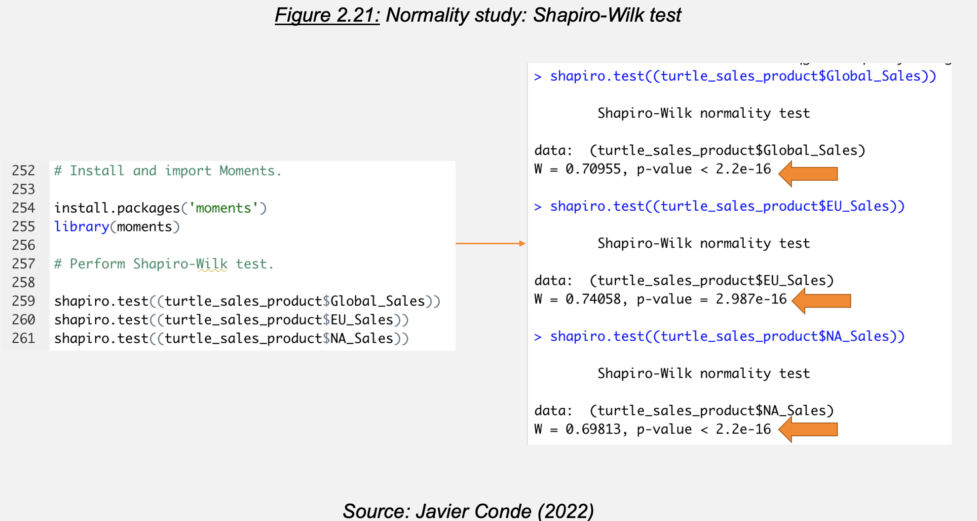

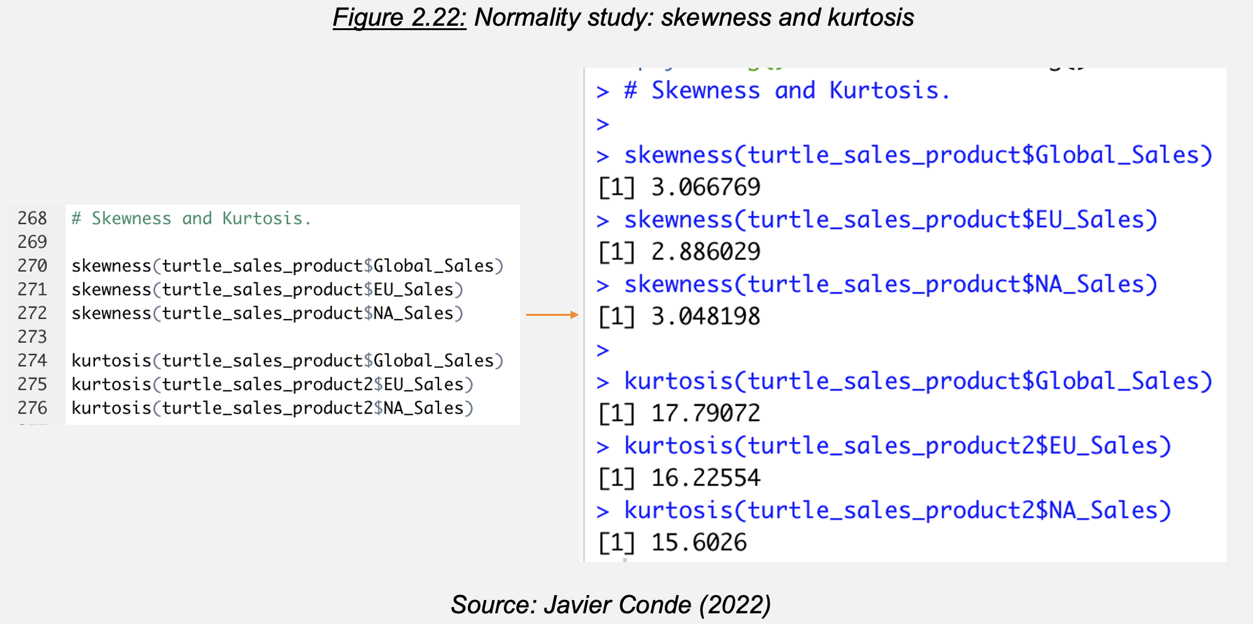

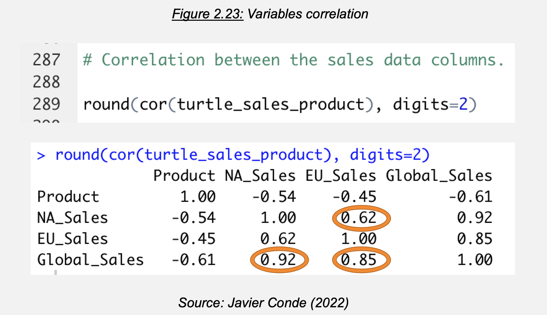

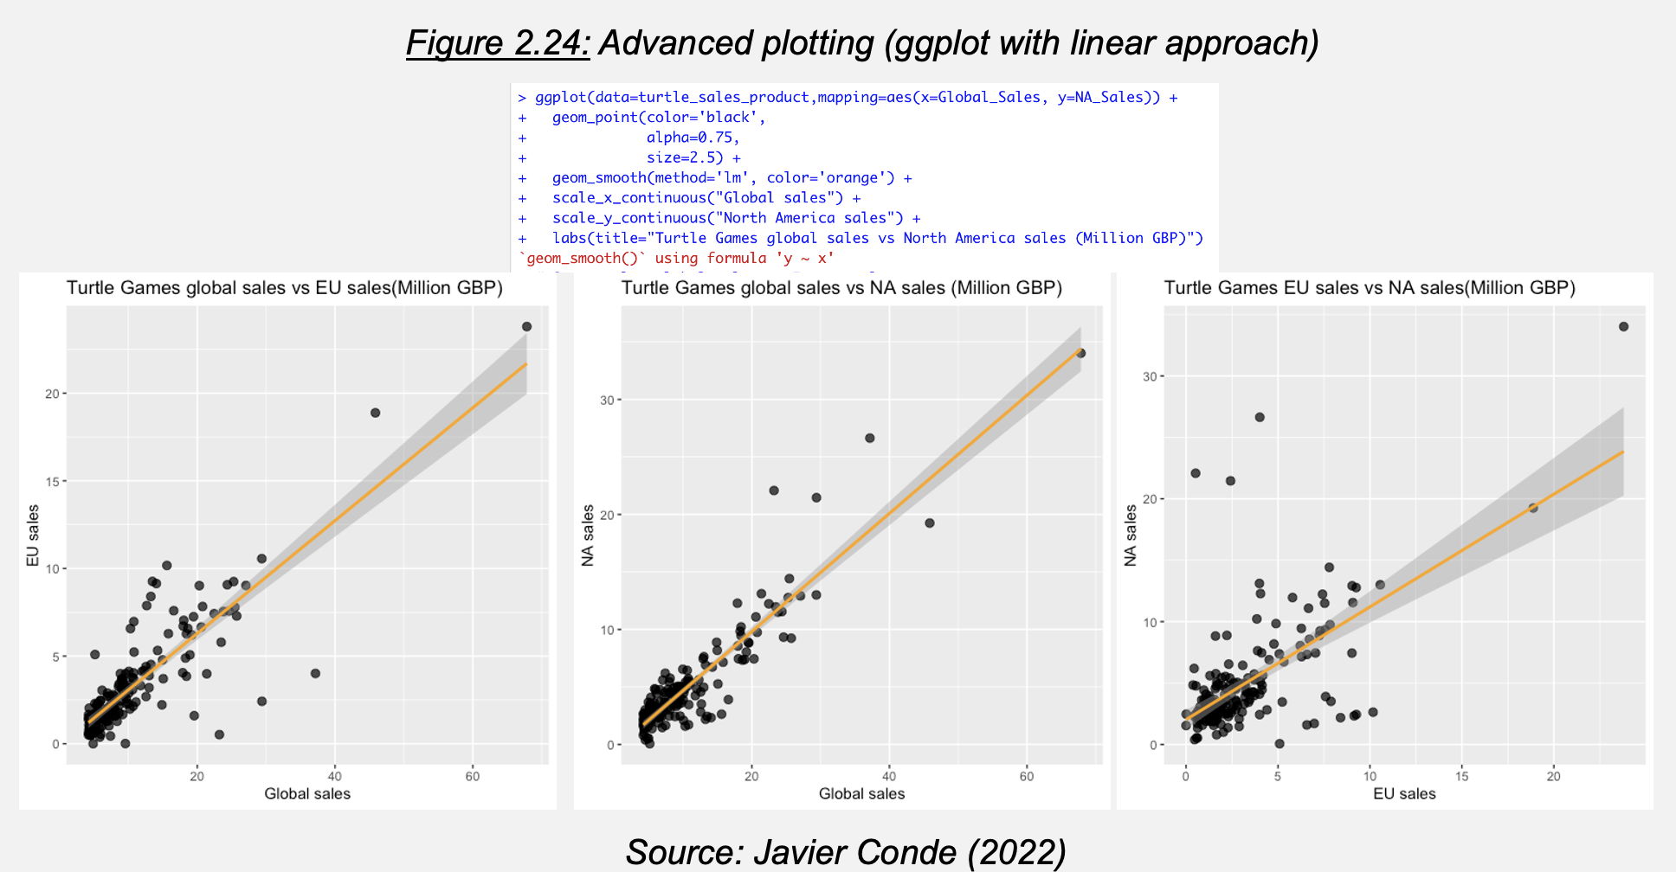

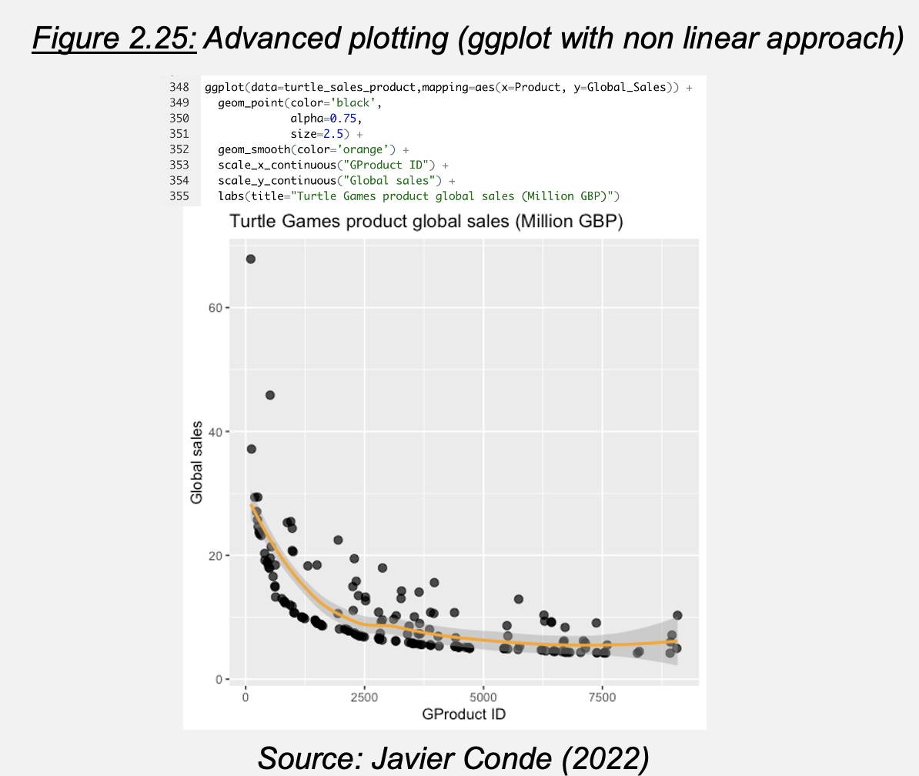

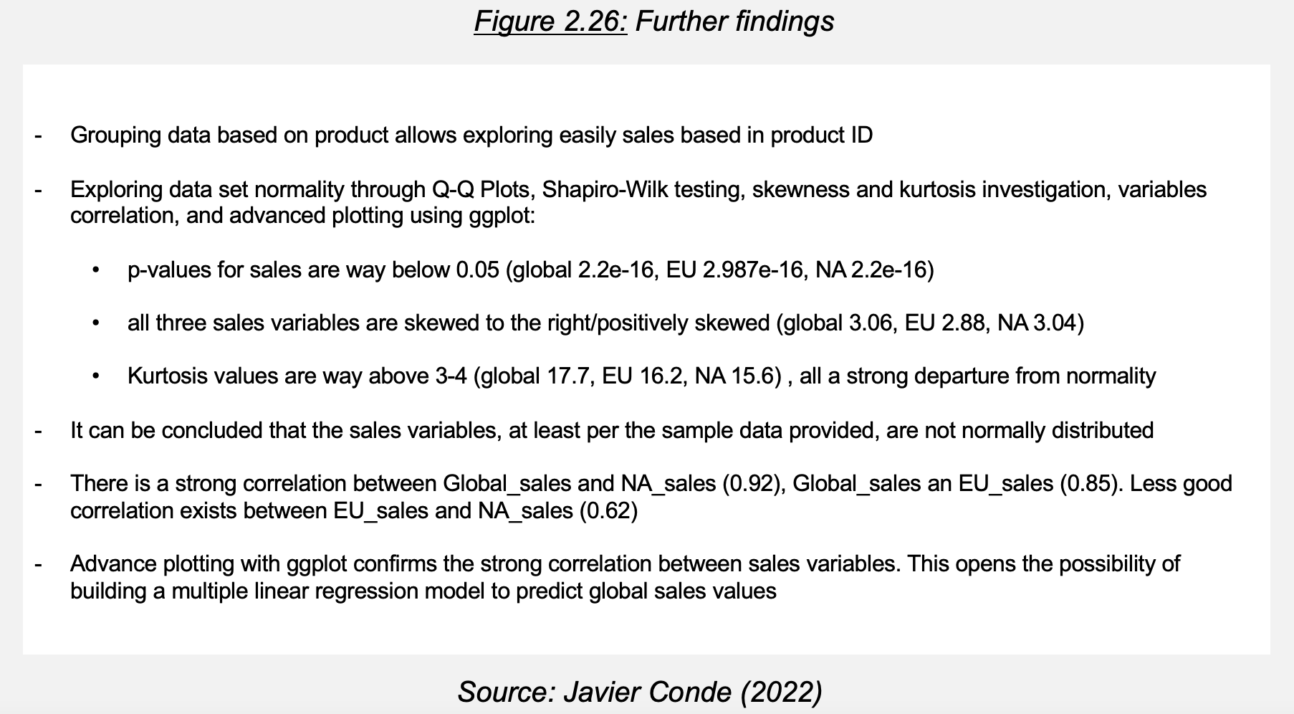

The findings (Figure 2.26) lead the project to conclusion evaluating how robust a potential multiple linear regression model could be.

**2.2.3. MLR model and value prediction**

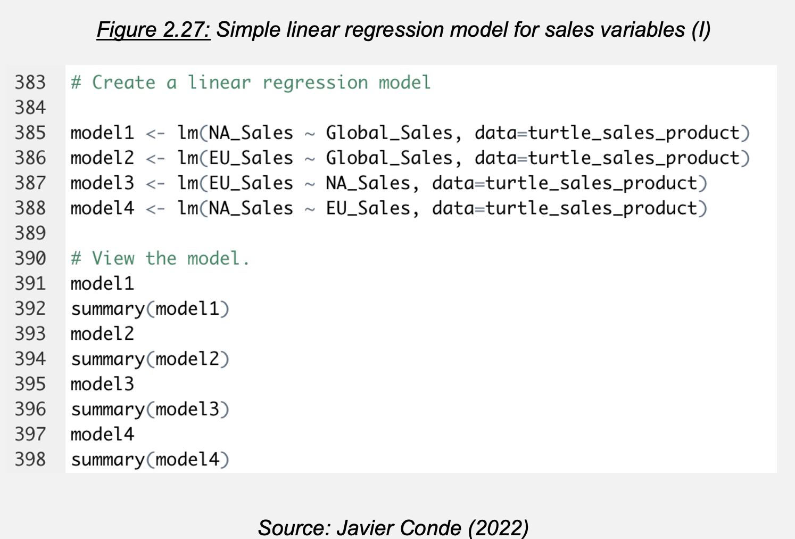

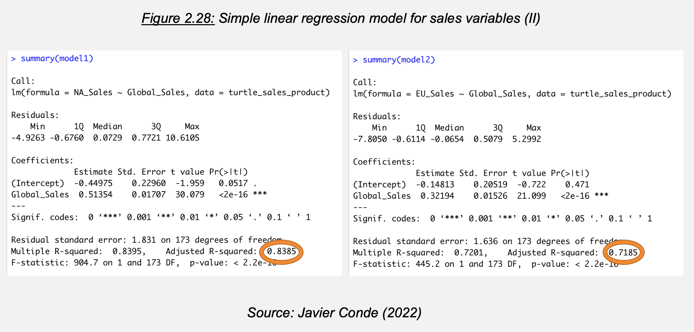

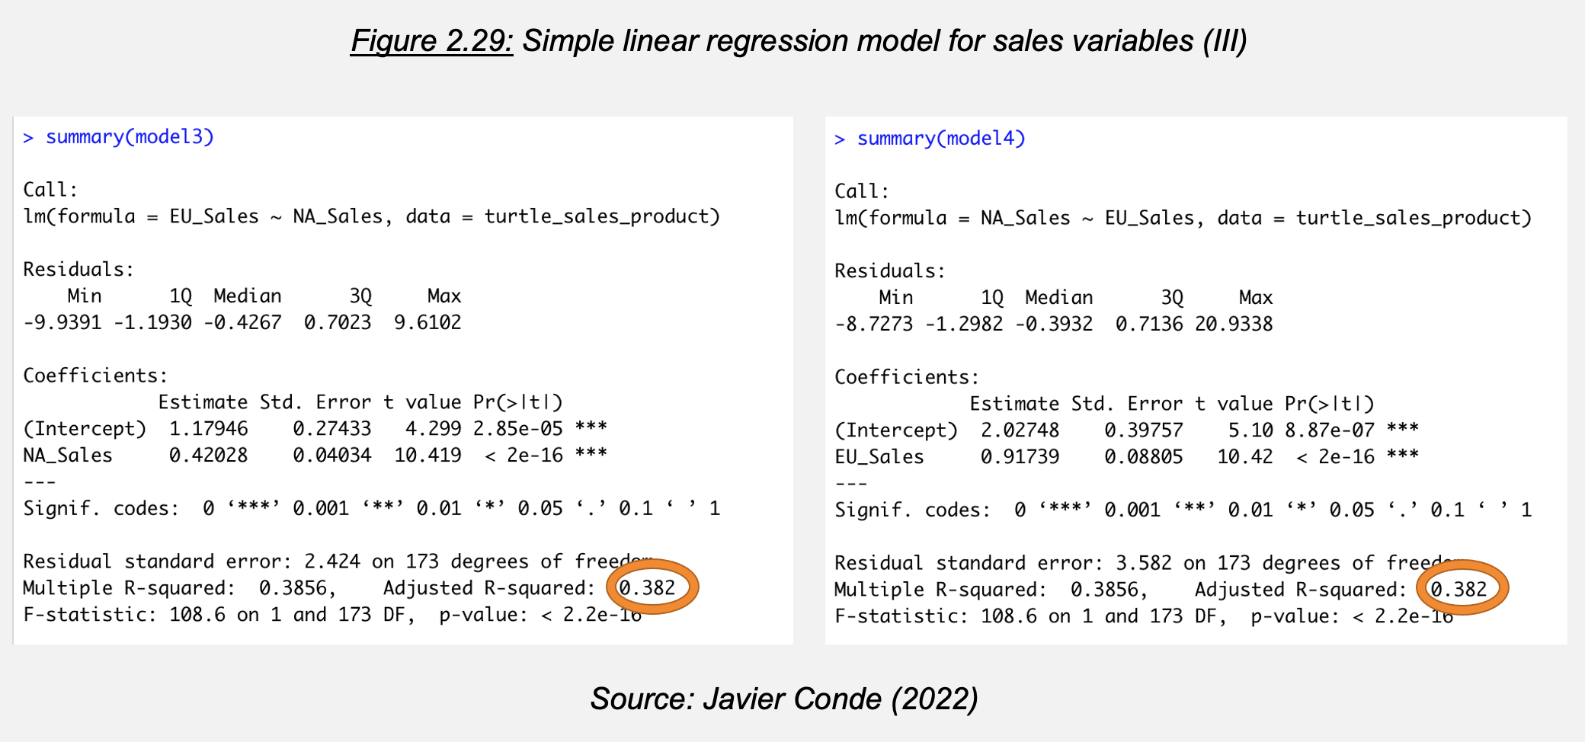

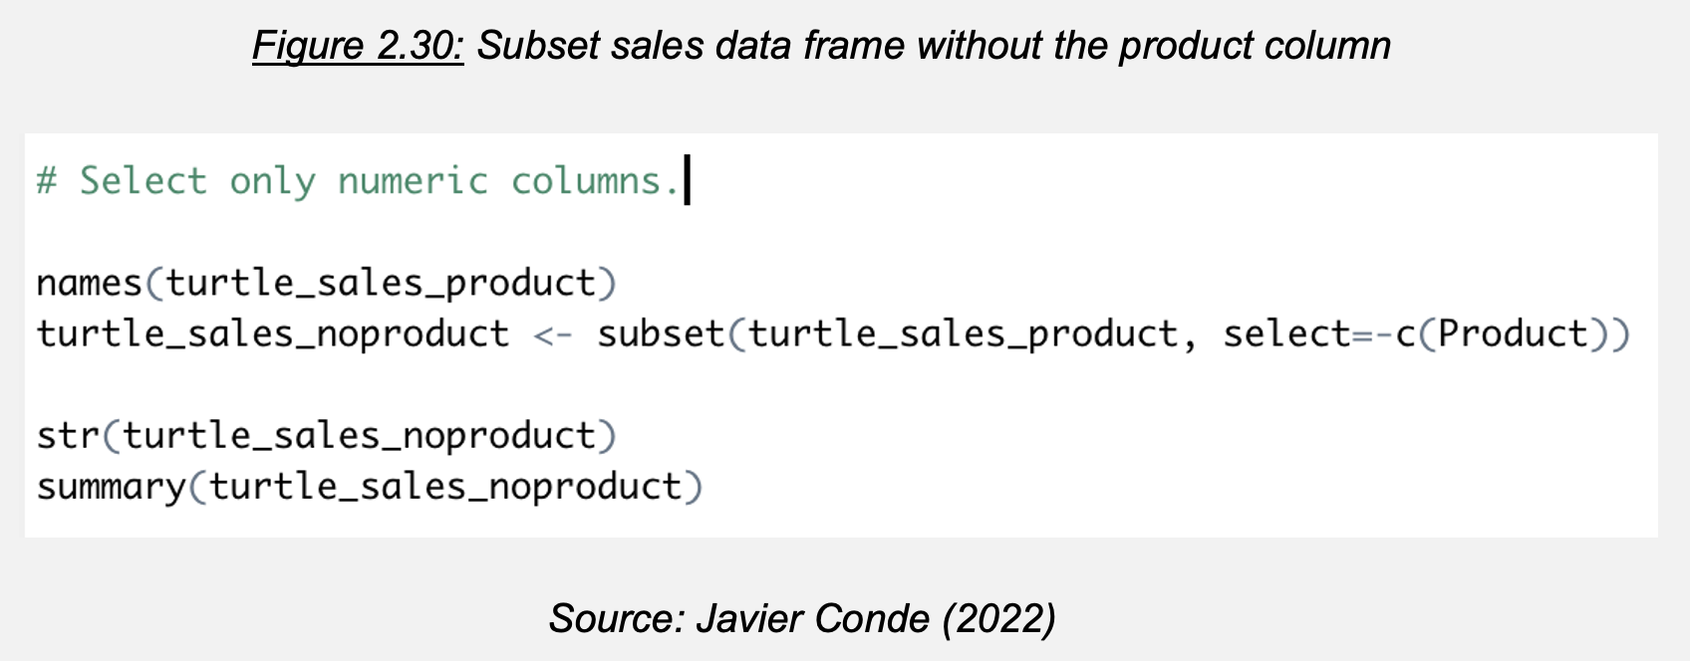

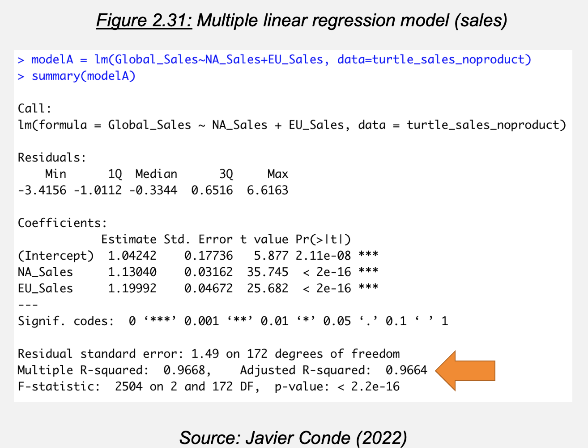

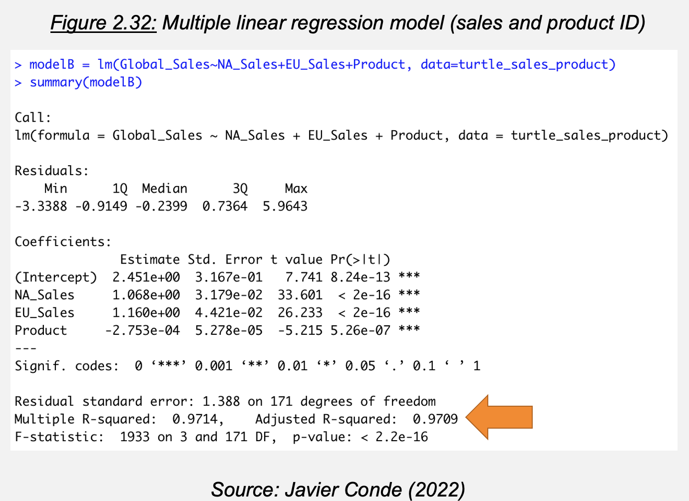

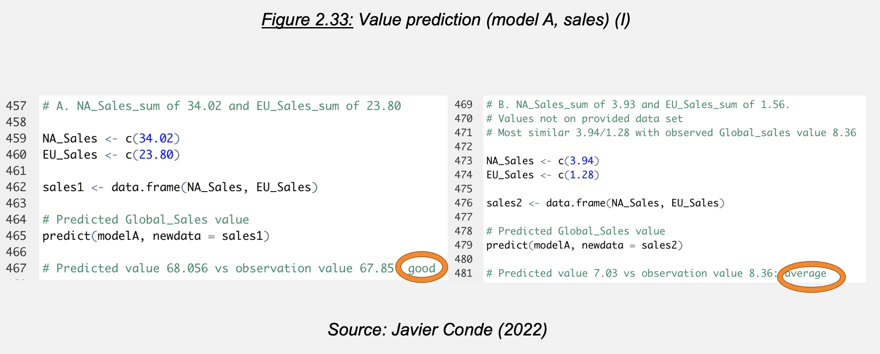

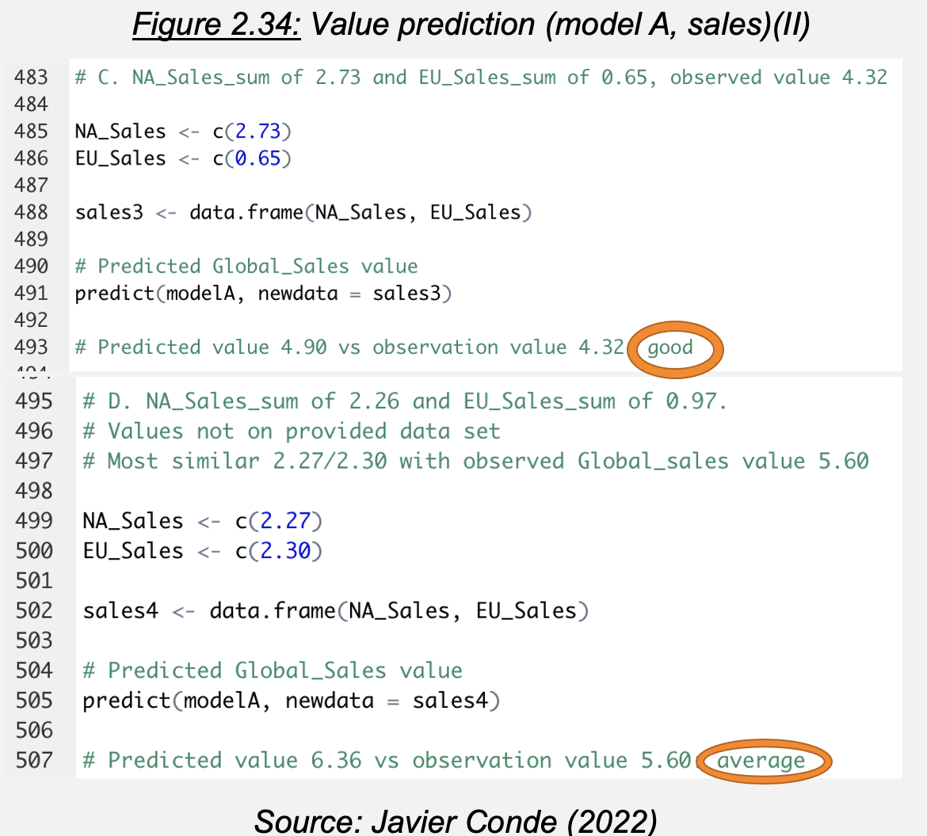

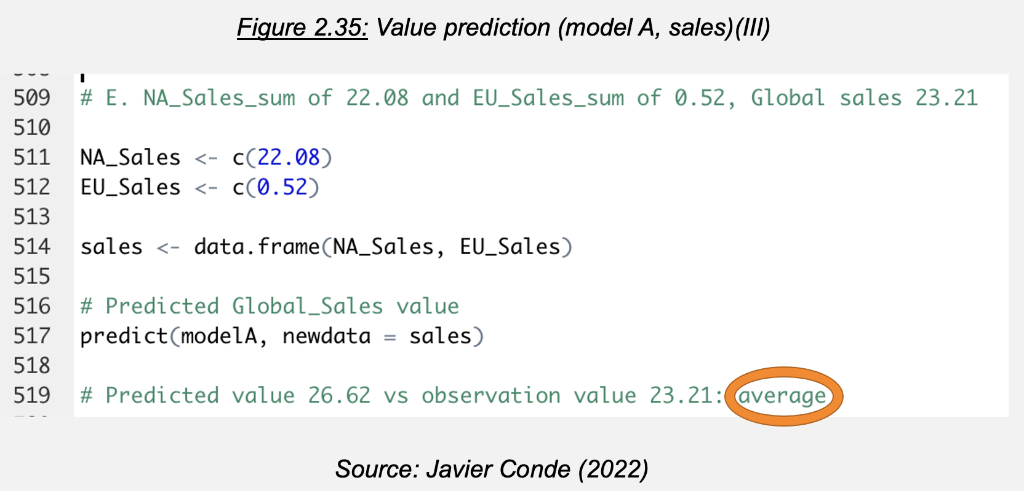

Chapter 3

**Insights and recommendations**

**List of Figures**

* Figure 1.1: Background, project goal and questions to answer (LSE, 2022)
* Figure 1.2: Project Github repository (I) (Javier Conde, 2022)
* Figure 1.3: Project Github repository (II) (Javier Conde, 2022)
* Figure 2.1: Data clean and re-import process (I) (Javier Conde, 2022)
* Figure 2.2: Data clean and re-import process (II) (Javier Conde, 2022)
* Figure 2.3: Loyalty vs spending, remuneration, age (Javier Conde, 2022)
* Figure 2.4: Remuneration/spending score Seaborn study: regression scatterplot (Javier Conde, 2022)
* Figure 2.5: Remuneration/spending score Seaborn study: pairplot (Javier Conde, 2022)
* Figure 2.6: Figure 2.6: k=5 (Elbow and Silhouette methods) (Javier Conde, 2022)
* Figure 2.7: K-means model for k=5, k=6, k=7 (Javier Conde, 2022)
* Figure 2.8: K-means chosen model for k=5 with clusters interpretation (Javier Conde, 2022)
* Figure 2.9: Data frame with ‘review’ /‘summary’ columns clean and ready for tokenisation (Javier Conde, 2022)
* Figure 2.10: Word cloud without stopwords from data frame (Javier Conde, 2022)
* Figure 2.11: Plot for the data frame 15 most frequent words (Javier Conde, 2022)
* Figure 2.12: Sentiment score polarity analysis for columns ‘review’ and ‘summary’ (Javier Conde, 2022)
* Figure 2.13: Import and exploration of ‘turtle_sales.csv’ provided file (Javier Conde, 2022)
* Figure 2.14: Data cleaning and subset creation: NA, duplicated observations, unnecessary columns (Javier Conde, 2022)
* Figure 2.15: Exploratory scatterplots with qplot (Javier Conde, 2022)
* Figure 2.16: Exploratory histograms with qplot (Javier Conde, 2022)
* Figure 2.17: Exploratory boxplots with qplot (Javier Conde, 2022)
* Figure 2.18: First observations and further exploration (Javier Conde, 2022)
* Figure 2.19: Data aggregation by product, overview and summary (Javier Conde, 2022)
* Figure 2.20: Normality study: QQ Plots (Javier Conde, 2022)
* Figure 2.21: Normality study: Shapiro-Wilk test (Javier Conde, 2022)
* Figure 2.22: Normality study: skewness and kurtosis (Javier Conde, 2022)
* Figure 2.23: Variables correlation (Javier Conde, 2022)
* Figure 2.24: Advanced plotting (ggplot with linear approach) (Javier Conde, 2022)
* Figure 2.25: Advanced plotting (ggplot with non linear approach) (Javier Conde, 2022)
* Figure 2.26: Further findings (Javier Conde, 2022)
* Figure 2.27: Simple linear regression model for sales variables (I) (Javier Conde, 2022)
* Figure 2.28: Simple linear regression model for sales variables (II) (Javier Conde, 2022)
* Figure 2.29: Simple linear regression model for sales variables (II) (Javier Conde, 2022)
* Figure 2.30: Subset sales data frame without the product column (Javier Conde, 2022)
* Figure 2.31: Multiple linear regression model (sales) (Javier Conde, 2022)
* Figure 2.32: Multiple linear regression model (sales and product ID) (Javier Conde, 2022)
* Figure 2.33: Value prediction (model A, sales) (I) (Javier Conde, 2022)
* Figure 2.34: Value prediction (model A, sales) (II) (Javier Conde, 2022)
* Figure 2.35: Value prediction (model A, sales) (III) (Javier Conde, 2022)